# Final Report: Empirically Evaluate Some Recent State-of-the-art Algorithms for Object Detection

**<Junaid Suleman, Wenbo Wu, Pengxiang Jia>**

**<April 12th, 2021>**

**Contents**

[**Final Report:  
  
Empirically Evaluate Some Recent State-of-the-art Algorithms for Object Detection**](#_2zby8pb82q59) **1**

Abstract 3

**1.Introduction** **3**

**2. Problem Formulation** **4**

**3.Background** **4**

**4. Approach** **5**

4.2 Dataset and Complications 5

4.3 HOG+SVM 6

4.4 Faster R-CNN 8

4.5 YOLO 10

5. Conclusion and Results 13

In order to get a visual representation of the results we chose an image not in the training, test or validation datasets and performed had all 3 of the algorithms perform object detection on the image with Faster RCNN using its Mask RCNN to also perform image segmentation as well to produce the following results. 13

**References** **14**

## Abstract

In recent years, various deep learning techniques have been applied to computer vision problems in object detection scenarios. The combination of computer vision and deep learning may bring relatively cheap and powerful solutions to many technical application fields. This paper proposes some empirical evaluations in state-of-the-art algorithms for object detection. We show how some existing convolutional neural networks (CNN) algorithms and support vector machines (SVM) with histogram of oriented gradients (HOG) can be used to perform pedestrian detection. Our results analyze some new deep learning algorithms in different object detection fields.

## 1.Introduction

There are many ways to kill time in today’s society. Many modern people like to kill time by reading comics and watching movies including anime and TV shows, especially during a time period where people are forced to stay home and find various hobbies to spend their time and as such the consumption of comic books, mangas, manhwa, etc. has increased. And a lot of the time these books are written in languages other than the reader's native language. Therefore, translating these books from one language to another is a lot of work. As such with this project we wish to attempt to streamline the process of possibly fetching the text from these books into an easy-to-read format that the translators can access without having to browse through all the pages. In addition, the detection part of the process can also be used to automatically remove text from images streamlining the process even further.

Moreover, with the development of the comic eras, the demand for manga adapted into anime is increasing; because there is a big gap in speed between production anime and drawing manga. We wish to reduce that gap and we can achieve that using Object detection.

Object detection is one of the more classical problems in computer vision. It mostly does so by generating a large number of bounding boxes and refines them to a location where it believes the object exists and then attempts to classify it. It is becoming more and more mature, from the traditional artificial design features plus shallow classifiers framework to the end-to-end object detection framework based on big data and deep neural networks. Now it is being widely used in various technical fields, including security, robotics, medical diagnosis etc. Especially in autonomous driving, the application and research fields for detecting obstacles such as pedestrians and vehicles are growing explosively. Many academic and industrial algorithms have been developed. They are roughly divided into three categories: traditional detection algorithm using SVM and extracted features, selective search with deep learning classification, and regression method based on deep learning.

For this paper we attempted to differentiate the exact empirical difference between two of the more known algorithms and how they fare in comparison to older techniques. The paper goes over the empirical evaluation of the following algorithms: An SVM that uses HOG as a feature extractor (traditional detection approach), The Faster R-CNN algorithm and the You Only Look Once (YOLO) in regression with deep learning.

## 2. Problem Formulation

Formally, out problem can be defined as that of object recognition, and then image segmentation of the produced bounding boxes and the detected objects. Which in our particular case arises from that of detecting speech bubbles in comic books or mangas. We aim to research how we can detect these speech bubbles via the use of machine learning and create a mask for them so that they can easily be edited by another program down the pipeline or a computer vision algorithm.

Therefore we start off by finding a suitable dataset, research the various algorithms available and train them on the dataset. Testing the various algorithms we can find the one to best represent our problem and then use it for image segmentation.

There are many types of object detection algorithms, some are traditional techniques and some are modern techniques that have been recently developed. The architectures differ from each other based on its accuracy, speed and hardware resources required. At present, the target detection algorithms appearing in academia and industry are divided into following three categories:

* Traditional approach of object detection
* Region proposal based framework
* Regression/Classification based framework

Each algorithm comes with its own characteristics and shortcomings, we will attempt to identify what mixture of these characteristics and shortcomings work best for our particular problem.

# 3.Background

The task of object detection is to find objects of interest in images or videos. To detect their positions and sizes at the same time, which is one of the basic tasks in the field of computer vision, and the academic field has a research history of nearly two decades. With the rapid development of deep learning technology in recent years, object detection algorithms have also shifted from traditional algorithms based on manual features to detection techniques based on deep neural networks. There are many uncertain factors in the object detection process. For example, the number of objects in the image is uncertain, the objects have different appearances, shapes, postures. Also, the interference of factors such as illumination and occlusion which makes the detection algorithm difficult.

The detection algorithm usually contains three parts, the first is the selection of the detection window, the second is the design of the feature, and the third is the design of the classifier. Early object detection methods extracted some robust features of the image such as Haar, scale invariant feature transform (SIFT), HOG, etc. Used the deformable part model (DPM), and used a sliding window to predict the higher score bounding box. After traditional object detection methods, the development of object detection in the deep learning era is mainly concentrated in two directions: two stage algorithms such as the faster R-CNN, other R-CNN series and one stage algorithms such as YOLO, single shot multibox detector (SSD), etc.

The main difference between these two approaches is that the two stage algorithm strategy is the same as traditional machine learning object detection. It requires candidate frames using an object proposal and then does the classification. It’s just that the multi-layer convolutional neural network (CNN) is now used to learn features. The one stage algorithm will use convolutional neural network (CNN) features without using Region Proposal network (RPN) by turning the object detection problem into a regression problem and directly extract features from the network to predict object classification and coordinate value. Some examples of algorithms will be explained in more detail in the approach section below.

# 4. Approach

We started off by researching and collecting information about the various algorithms and methods deployed to solve the issue of object detection. In particular, we looked at methods that used computer vision for feature extraction and convolutional neural networks that did the extractions themselves. Based on the implementations, complexity and features of the various methods we grouped them by those that we were interested in and those that wouldn’t work or were particularly ill matched for our problem scope.

We initially picked 5 different methods to try based on the members of our group. We wanted to get a good representation of both traditional methods and the newer convolutional networks, but had to drop 2 of them methods as group members left. In the end we chose the Faster-RCNN (Regional Convolutional Neural Network) and YOLO (You Only Look Once) algorithms to represent the convolutional network approach to the problem and the Histogram of Gradients Descriptor computer vision algorithm to extract features and feed them into an SVM to represent the traditional approach.

### 4.1 Dataset and Complications

As initially planned, we weren't able to find many datasets or even a single premade dataset for our problem definition. Researching into it a bit, we found that generating datasets for this particular problem is a bit challenging due to the nature of the work involved in creating the initial manga or comics. The copyrighted nature of the images make it extremely difficult to label them and open source them for machine learning projects. Due to time constraints we were also unable to create our own labels for the project. Therefore we decided to reduce the problem to using a different dataset which in this case we chose walking pedestrians as it represented the complexity of our original proposed issue. Both bubbles and pedestrians appear in areas with a lot of other objects in the scene and varying shapes and sizes and sometimes grouped together.

So with the reduction/mapping in mind we chose the Penn Fudan Database for Pedestrian Detection and Segmentation. The particular dataset has 170 images with 345 labeled pedestrians with labeled heights varying from 180px to 390px. The small size of the dataset maps correctly to the limited number of images we would be able to label for the detecting speech bubbles.[3]

4.2 HOG+SVM

HOG is a feature descriptor for images. An image is a group of pixels in a matrix structure; a feature descriptor traverses the rows and columns of the matrix to obtain the information and organize them corresponding to the spatial structure of pixels in the matrix. In the case of HOG, gradient is the feature. Gradient is calculated based on pixel values. A very small piece of the image would form one gradient if it contains rapid shift in pixel intensities; the gradient oriented itself along the topography of the pixel intensities in the piece. In the visualization of gradients, the gradients are organized according to the same spatial structure of the image, we can clearly see the gradients are trying to describe where the edges are in the image.

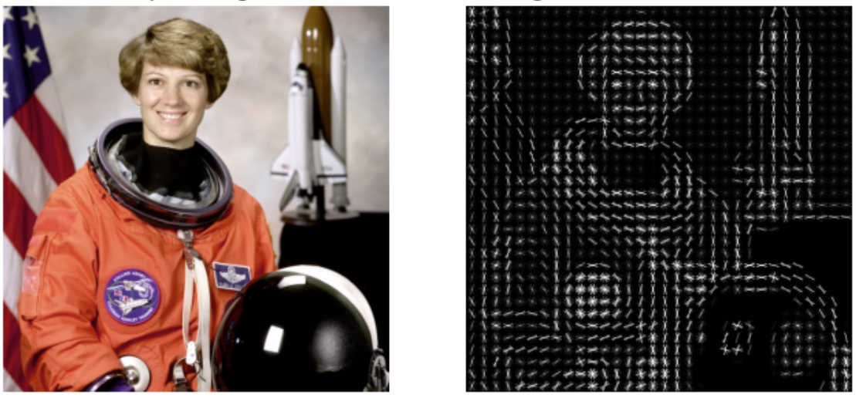

*Figure: gradients that describe edges*

If we fix an image onto the xy-axis, Sobel operator as one of the major methods to find gradient, it finds both the gradients in x and y direction of a 3x3 matrix of pixels from the image, denote them as Gx and Gy. Then $arctan\frac{Gy}{Gx}$, $\sqrt{{Gx}^{2}+{Gy}^{2}}$ give the direction and magnitude of the resulting gradient we are finding for the small square of pixels. The next step after knowing how to obtain gradients is sorting them into a histogram. In the visualization of gradients on above figure, each separate little dot is a histogram being visualized, a histogram is represented by crisscrossing gradients in discretized angles in 360 degree, the brightness of each line indicates the gradient’s magnitude in that direction.

In order to detect pedestrians, the HOG-SVM model was firstly trained on preprocessed examples from the dataset. One important preprocessing step is to crop out pedestrians from every bounding box of the dataset. Bounding boxes are provided and specified in the annotation files along with the dataset. I read out all the information and cropped out pedestrians then saved them as images. If the cropped out images are not in uniform width or height, I specified the every pedestrian image to be (40, 110). Resizing images can be done using some functions from image processing libraries. The reason for doing this is that the feature vectors to input to SVM need to be all in the same size, and also (40, 110) is a small size that allows training to be fast.

In order to make the model be sensitive to a HOG feature of pedestrian’s shape, such that it “detects” pedestrians, the model needs to be trained on images that contain only one pedestrian. The training process split these examples into 70% training, 20% validation, and 10% testing. There are cross-validation training to tune for best parameters. The feature vector to be input to SVM (sklearn’s) consists of HOG vector produced by Skimage or Opencv’s HOG descriptor, and some additional features such as color histogram and raw pixel values after scaling down the image. The additional features are customizable, but the HOG feature is not replaceable

After training and obtaining good test results, the trained model will be utilized for generating windows for pedestrians in brand new input images that the SVM has never seen. There can be more than one pedestrian in a single image, so the program should give a window to each of them. Sliding window technique is simple and effective for this purpose. The process of sliding window search is firstly specifying coordinates of two corners of the window in its diagonal, then we run the trained SVM on this window to see if this patch of image in the window contains a pedestrian. If the SVM was nicely trained, it is able to determine if a (40, 110) image contains a pedestrian. Choice of the positions of windows is unrestricted. In order to effectively detect pedestrians, In my implementation of sliding windows, I programmed the windows to verify every square of the image from left to right, up to down sequence. The window searches in two directions, and moves by 20 pixels each time.

The result of my implementation of the HOG+SVM model was largely unsatisfactory. I observe many false positives and false negatives, the current capability of the classifier is detecting obvious pedestrians when there are no overlapping of two targets, when the target doesn’t only half appear. The most severe deficiency of my result is false positive classification, I suspect the cause for that is the model was not trained on enough negative examples where pedestrians don’t appear. A probably very effective method that I found on the Internet is Hard-Negative mining, in which we collect the false-positive examples and specifically retrain the SVM model with them, we can also multiplicate these false-positive examples in training set by the frequencies they cause false-positive results in last training.

**4.3 Faster R-CNN**

Faster R-CNN is the predecessor to Fast R-CNN and R-CNN. It utilises a Region Proposal Network (RPN) that shares full-image convolutional features with the detection network and does so in a more cost effective way than either R-CNN or Fast R-CNN which use selective searching. It extracts features form an image with a CNN and feeds that into the RPN which simultaneously predicts the object bounds as well as objectness scores at each position of the object and is trained end-to-end to generate high-quality region proposals, which are then used by Fast R-CNN for detection of objects.

To implement Faster-RCNN we chose the class provided by the [Pytorch](https://pytorch.org/) module due to its ease of use and upto date libraries compared to that of tensorflow. The dataset was split into a training and validation set with the split being 70% - 30%. After which the training data is imported into the project scope and transformations are applied to the training dataset to increase its size, effectively increasing the size of the training data to 2 times that of the original size.

To get a measure of the implementation and algorithm, we trained the model using random starting values but ended up with poor results. The process of training the Faster-RCNN model contains 3 steps. First you train the model for 1 epoch, based on the results of the training error and IOU metrics you update the learning scheduler, evaluate the model and repeat the process for the selected number of epochs.

In order to get better results we decided that it would be best to have a backbone for our Faster-RCNN to overcome the burden provided by using a smaller dataset for training and as such we incorporated resnet_50 as a backbone for the Faster-RCNN algorithm. Furthermore, our model also uses a Stochastic Gradient Gradient Descent optimizer that optimizes the learning rate for the model based on the training loss and IOU metrics generated during the epoch training.

After setting up all the new variables we trained the model for a total of 100 epochs to see how the training error and validation score change over multiple epochs. The following graph shows the result of the training.

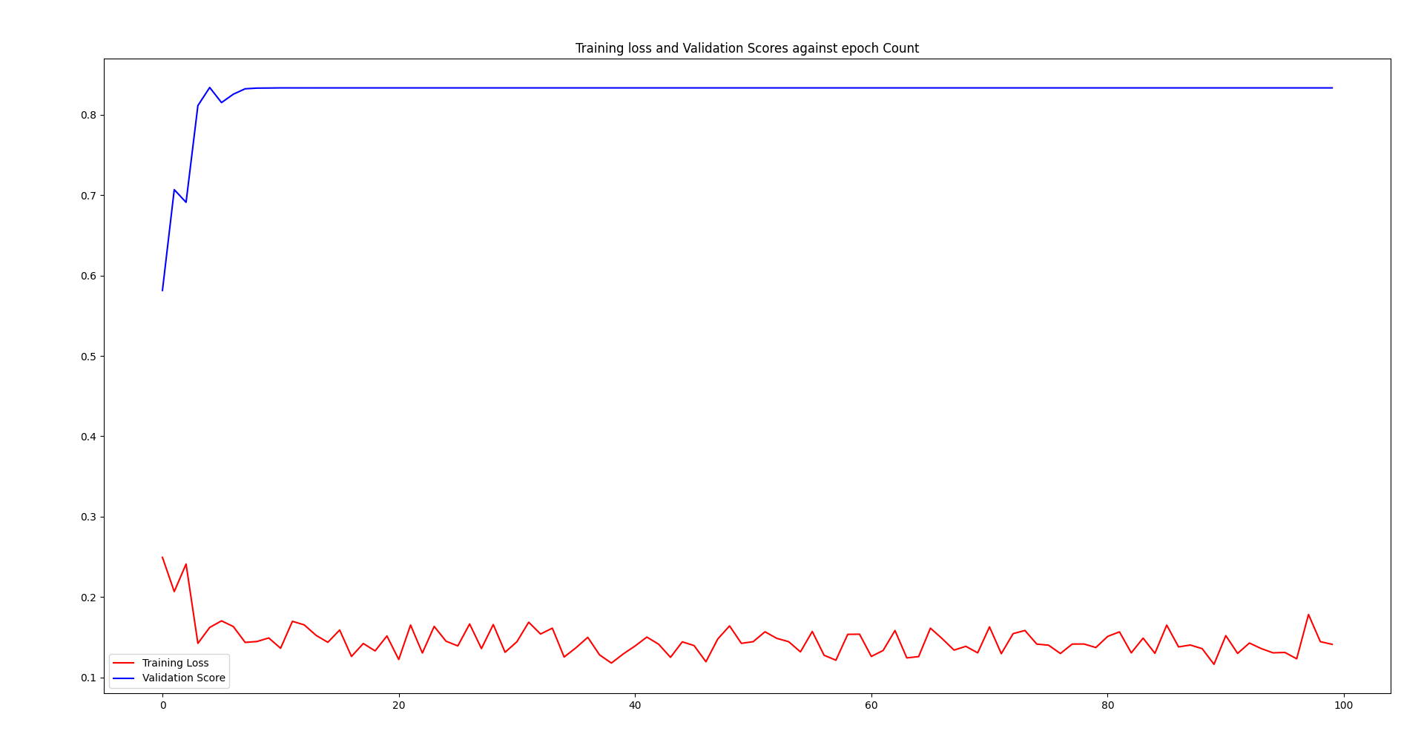

The training loss continues to vary and fluctuate all across the epoch training however we can see a sharp and continuous decline over the first new epochs, similarly the validation score increases over the first 10 epochs.

After the initial test we looked into hyperparameter tuning and researched the more professional methods used for it. And as such tried an implementation of RayTune which ended up not producing any good results due to the lack or required hardware to do the computation associated with the functionality they provide. In the end we fell back to doing maula hyperparameter tuning in which surprisingly a lot of the parameter changes to the optimizer and learning rate scheduler caused the training to terminate after the first epoch while also not being able to produce better results. The following 2 graphs show the result of the parameter tuning for the optimizer and learning rate scheduler.

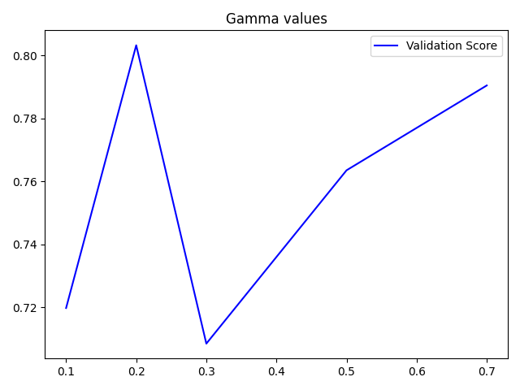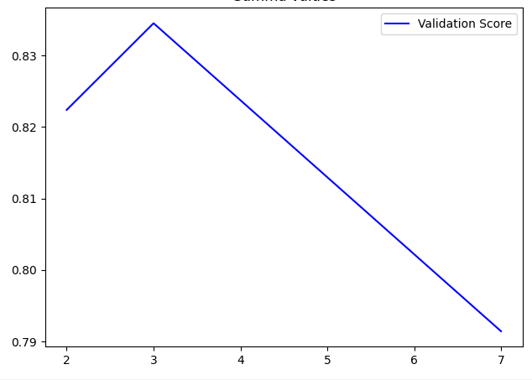

*Gamma Values Step Size*

The results of the Hyperparameter tuning were as follows: For the optimizer the starting learning rate was 0.005, with a momentum and weight decay of 0.9 and 0.0005 respectively; and for the learning rate scheduler the step size was best set as 3 and gamma as 0.2.

Finally we also experimented with implementing MaskRCNN on top of the Faster RCNN to generate pixel based masks. We did so by using the roi_heads mask predictor for the Mask RCNN class to use the Mask RCNN predictor and the box predictor to use the Faster RCNN Predictor with a total of 256 hidden layers, which when trained on the dataset using the parameters from the tuned model produced the following IOU metrics and graph both of which show good accuracy and classifications.

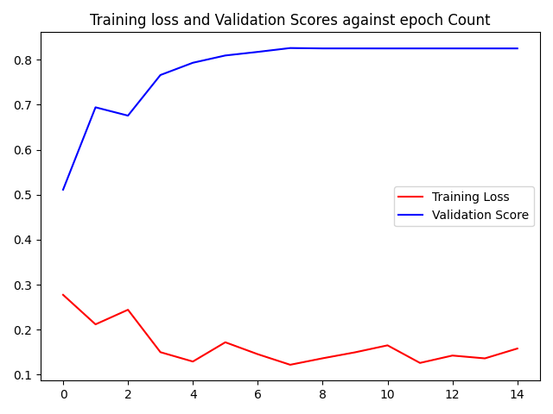

### 4.4 YOLO

All of the previous object detection algorithms use regions to localize the object within the image. The network does not look at the complete image, instead it looks at parts of the image which have high probabilities of containing the object. The essence of object detection is regression, so a convolutional neural network that implements the regression function does not require a complicated design process. The algorithm YOLO proposed by Redmon is a novel object detection algorithm much different from the region based algorithms such as the algorithms seen above. In this section, we will give detailed information to the principle and the experiments of the YOLO algorithm.

YOLO is one of the most advanced real-time object detection algorithms. It is the preferred algorithm of many data scientists and machine learning engineers when it comes to real-time object detection. It is mainly composed of three main components, the first component is the backbone. It is a convolutional neural network that aggregates and forms image features on different images. The second part is the neck, it’s a series of network layers that mix and combine image features, and pass the image features to the prediction layer. The third component is the head which predicts image features, generates bounding boxes and predicts categories.

What YOLO does is that it divides up the image into a grid of S x S cells. Each of the cells is responsible for predicting some bounding boxes. It will predict what the classes are for each of the bounding boxes and then feed the bounding boxes to the neural network. It outputs a confidence score that tells us how certain it is that the predicted bounding box actually encloses some object. The confidence score for the bounding box and the class prediction are combined into one final score that represents the probability that this bounding box contains a specific type of object.

The evaluation in this section will use YOLO v5 released by Ultralytics in 2020. Due to time constraints, the batch size of model training will be limited under 64. YOLO uses an end-to-end training method to connect feature extraction, candidate frame prediction, non-maximum suppression and object recognition. Therefore, we first trained the model with image size 640x640, 64 batch size 64 and ran for 100 epochs to see its results.

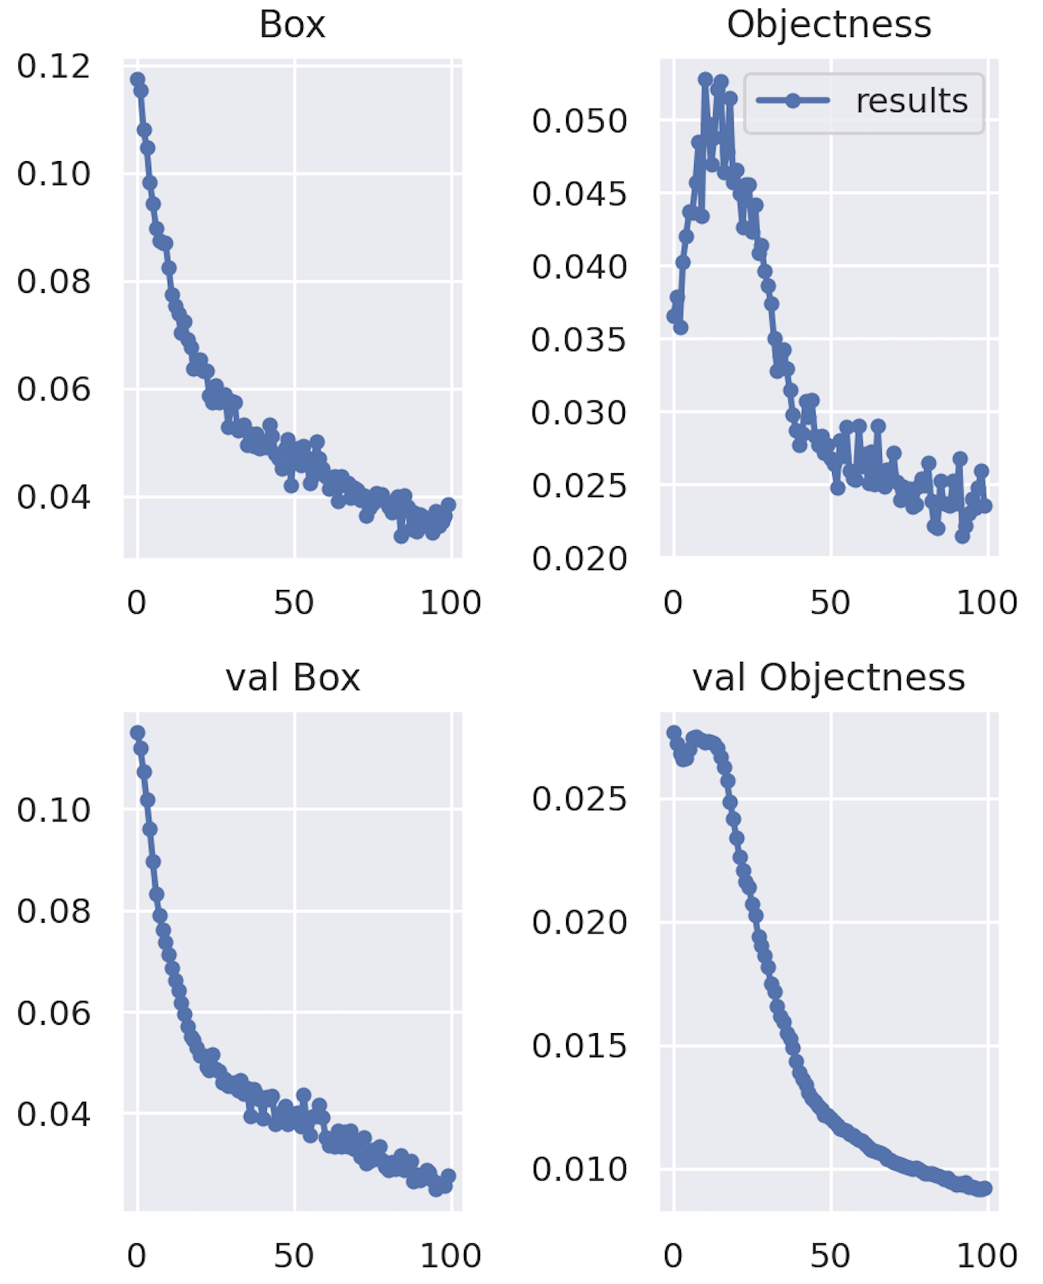 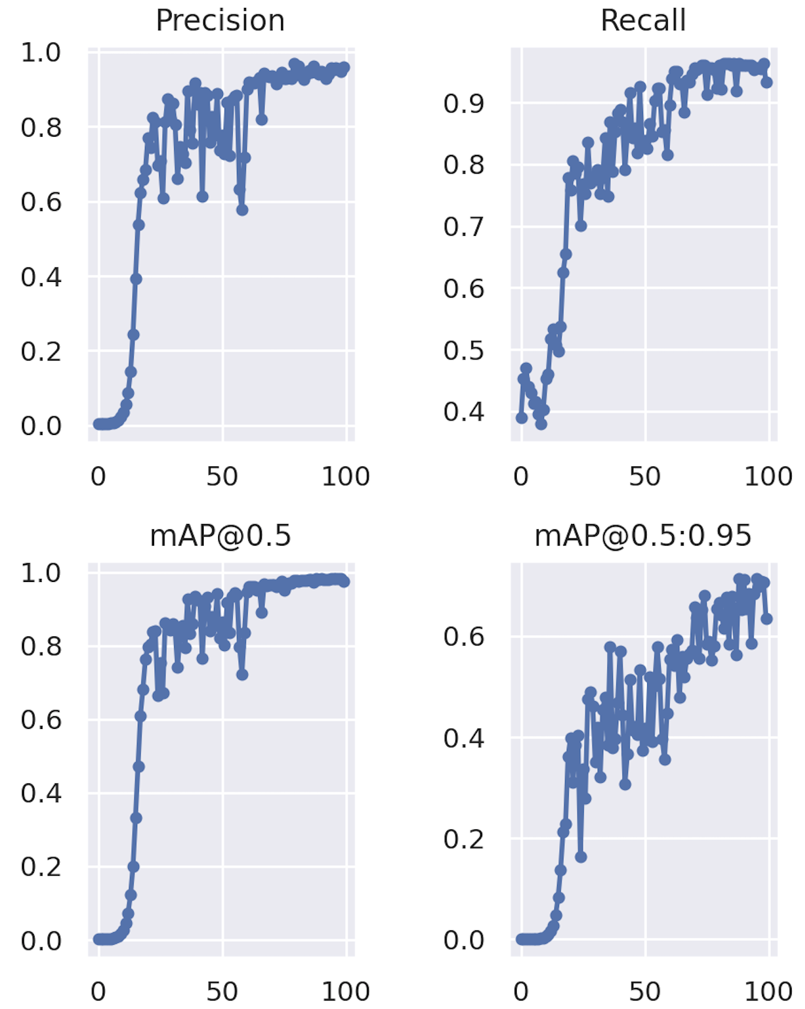

***Figure :*** Result for experiment of 100 epochs with 64 batch size.

It took 5 minutes for training to complete on a AMD 4GB GPU. The result of the above figure shows the generalized intersection over union (GIoU), the probability that an object exists in images, and mean average precision (mAP). It is seen that GIoU loss and objectness loss decrease both for training and validation. And the mAP is at 0.9, but the mAP only reaches 0.7 at 0.5 to 0.95. Figure below shows the prediction of some testing examples and shows the prediction bounding boxes with its probability. The prediction of most of the objects in the examples is around 70%, but they are all perfectly labeled, including the pedestrians who are on bicycles and people in the distance.

## 

***Figure :*** Predict examples based on the first training mode.

In order to achieve a higher degree of accuracy, we increased the model training epoch to 300. It increased the accuracy to 90% shown in the figure below. Although the prediction for the far detection object is still less than 90%, its position can be predicted perfectly and the appropriate bounding box can be labelled around it. Since the data used in this project is images, we did not conduct real-time testing and evaluation of the algorithm. Based on the fact that YOLO is one of the algorithms in one stage, the algorithm is able to detect multiple objects at once; it is faster than other algorithms in real-time detection.

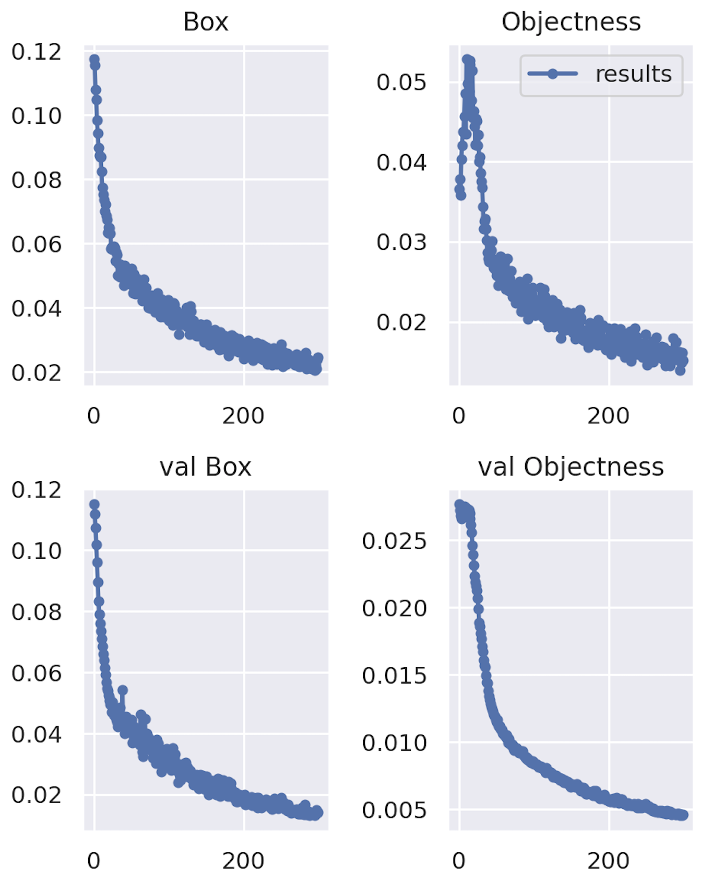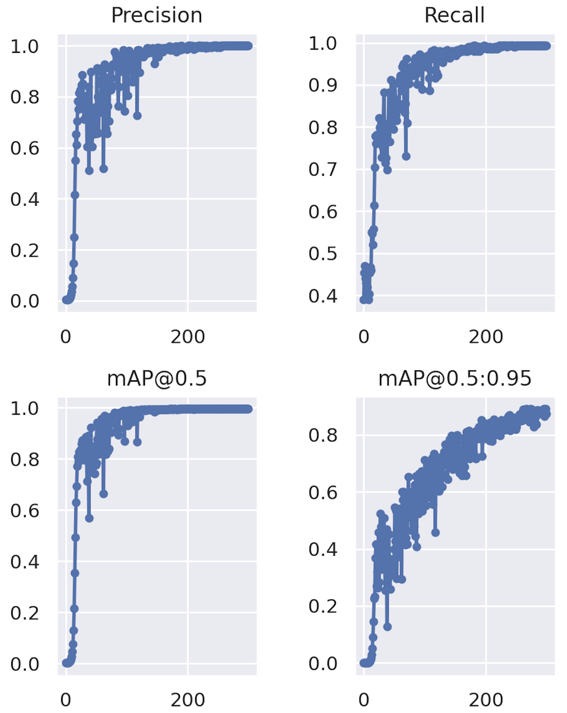

***Figure :*** Result for experiment of 300 epochs with 64 batch size.

## 5. Conclusion and Results

## In order to get a visual representation of the results we chose an image not in the training, test or validation datasets and performed had all 3 of the algorithms perform object detection on the image with Faster RCNN using its Mask RCNN to also perform image segmentation as well to produce the following results.

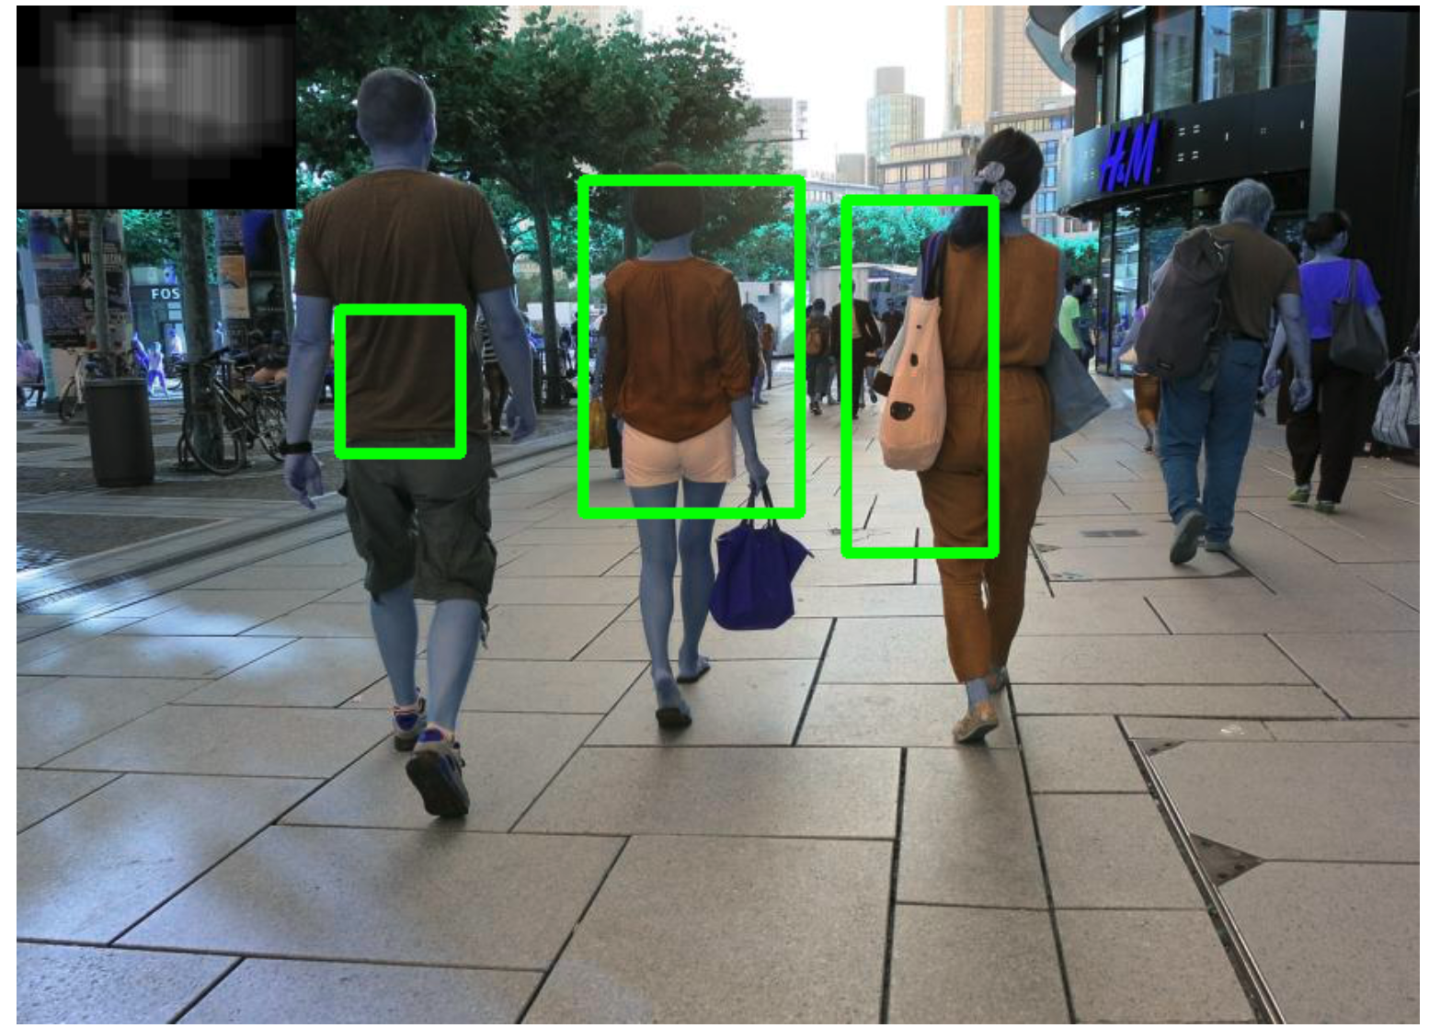

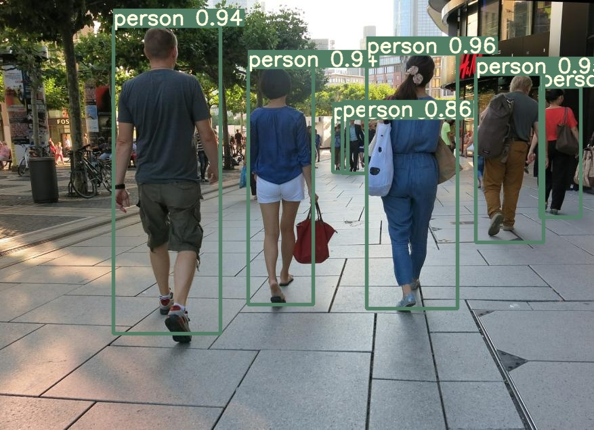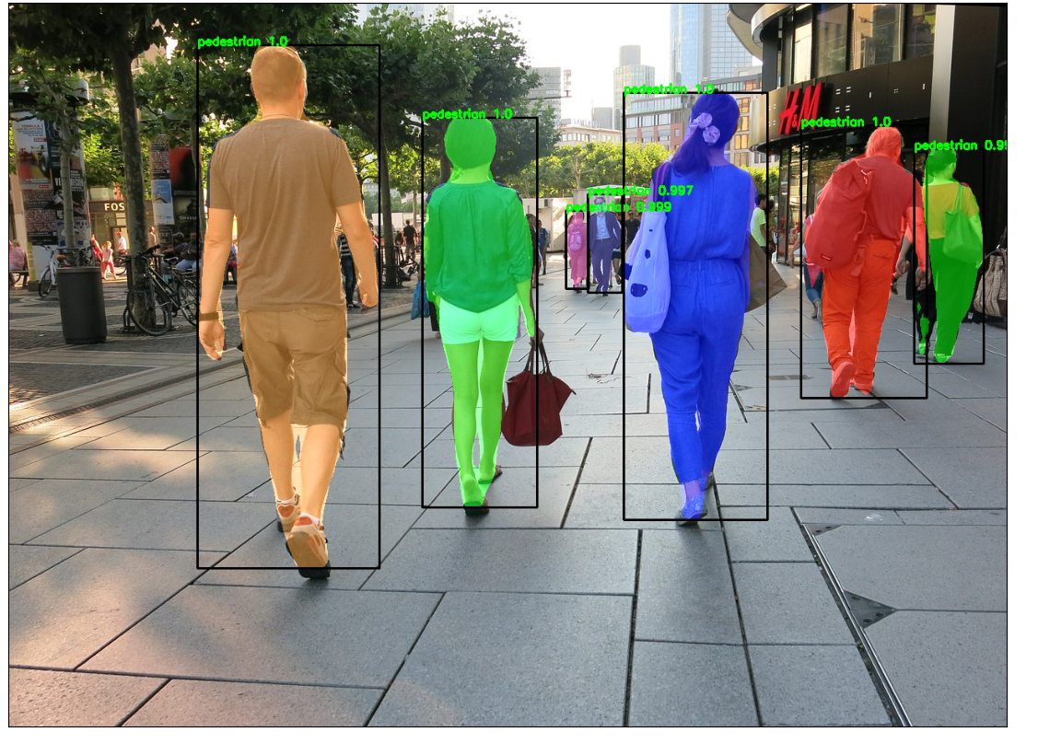

*From top left to bottom right: HOG+SVM, MaskRCNN and YOLO*

Both the MaskRCNN (Faster RCNN) and YOLO models did extremely well while the HOG+SVM had a hard time getting the exact bounding boxes while also missing a lot of the objects in the image. We think the issue lies within the size of the dataset and the issue of multiple objects in the image that leads to misclassification with HOG+SVM model. Both the YOLO and the Mask-RCNN models were trained using a GPU and YOLO seemed to be the faster of the two in terms of training time. When it came to the speed of inferencing YOLO still seemed to be slightly faster however that might be attributed to the additional task of generating an image segmentation mask.

From these results we can infer that while using MaskRCNN and YOLO as long as we have a large enough labeled dataset, with a bit of hyperparameter tuning we should easily be able to solve the issue for finding speech bubbles in a comic book. Some of us plan to create the labeled data in the next few months and use the information and results from this study to complete the initial proposal.

## 

## References

[1] Kuboi, Toshihiro. (2014). ELEMENT DETECTION IN JAPANESE COMIC BOOK PANELS. 10.13140/2.1.1009.4409.

[2] Dubray, David & Laubrock, Jochen. (2019). Deep CNN-based Speech Balloon Detection and Segmentation for Comic Books. Retrieved from: [1902.08137v1.pdf (arxiv.org)](https://arxiv.org/pdf/1902.08137v1.pdf)

[3] *Pedestrian Detection Database*. www.cis.upenn.edu/~jshi/ped_html/.

https://papers.nips.cc/paper/2015/file/14bfa6bb14875e45bba028a21ed38046-Paper.pdf

https://www.cv-foundation.org/openaccess/content_cvpr_2016/papers/Redmon_You_Only_Look_CVPR_2016_paper.pdf

<https://software.intel.com/content/www/us/en/develop/documentation/ipp-dev-reference/top/volume-2-image-processing/computer-vision/feature-detection-functions/histogram-of-oriented-gradients-hog-descriptor.html>

Appendix

| IoU metric: bbox  Average Precision (AP) @[ IoU=0.50:0.95 | area= all | maxDets=100 ] = 0.823  Average Precision (AP) @[ IoU=0.50 | area= all | maxDets=100 ] = 0.993  Average Precision (AP) @[ IoU=0.75 | area= all | maxDets=100 ] = 0.941  Average Precision (AP) @[ IoU=0.50:0.95 | area= small | maxDets=100 ] = -1.000  Average Precision (AP) @[ IoU=0.50:0.95 | area=medium | maxDets=100 ] = 0.626  Average Precision (AP) @[ IoU=0.50:0.95 | area= large | maxDets=100 ] = 0.829  Average Recall (AR) @[ IoU=0.50:0.95 | area= all | maxDets= 1 ] = 0.317  Average Recall (AR) @[ IoU=0.50:0.95 | area= all | maxDets= 10 ] = 0.863  Average Recall (AR) @[ IoU=0.50:0.95 | area= all | maxDets=100 ] = 0.863  Average Recall (AR) @[ IoU=0.50:0.95 | area= small | maxDets=100 ] = -1.000  Average Recall (AR) @[ IoU=0.50:0.95 | area=medium | maxDets=100 ] = 0.822  Average Recall (AR) @[ IoU=0.50:0.95 | area= large | maxDets=100 ] = 0.866  IoU metric: segm  Average Precision (AP) @[ IoU=0.50:0.95 | area= all | maxDets=100 ] = 0.776  Average Precision (AP) @[ IoU=0.50 | area= all | maxDets=100 ] = 0.993  Average Precision (AP) @[ IoU=0.75 | area= all | maxDets=100 ] = 0.929  Average Precision (AP) @[ IoU=0.50:0.95 | area= small | maxDets=100 ] = -1.000  Average Precision (AP) @[ IoU=0.50:0.95 | area=medium | maxDets=100 ] = 0.435  Average Precision (AP) @[ IoU=0.50:0.95 | area= large | maxDets=100 ] = 0.786  Average Recall (AR) @[ IoU=0.50:0.95 | area= all | maxDets= 1 ] = 0.297  Average Recall (AR) @[ IoU=0.50:0.95 | area= all | maxDets= 10 ] = 0.806  Average Recall (AR) @[ IoU=0.50:0.95 | area= all | maxDets=100 ] = 0.806  Average Recall (AR) @[ IoU=0.50:0.95 | area= small | maxDets=100 ] = -1.000  Average Recall (AR) @[ IoU=0.50:0.95 | area=medium | maxDets=100 ] = 0.733  Average Recall (AR) @[ IoU=0.50:0.95 | area= large | maxDets=100 ] = 0.811 |
| --- |